Fair and Transparent Blockchain based Tendering Framework - A Step Towards Open Governance

<https://arxiv.org/pdf/1805.05844.pdf>

**1. Abstract:**

As society’s values have shifted, so have expectations of government shifted from the traditional model to something commonly referred to as ‘open governance’. We take open governance to mean a concept, which encourages and facilitates openness, accountability, and responsiveness to citizens.

These technologies enable access to both the data and to engagement activities between citizens and government. Blockchain can play important role in Open Governance, as potentially a vital building block to realising open and transparent government activities.

**2. Component Architecture diagram and its description:**

**C**entral entity government who create tender for certain period of time, bidder publish bid, no one see others bids, all bids can be reviewed after given period expired. On bids government give review and publish, citizens can review these bids. Central entity blockchain.

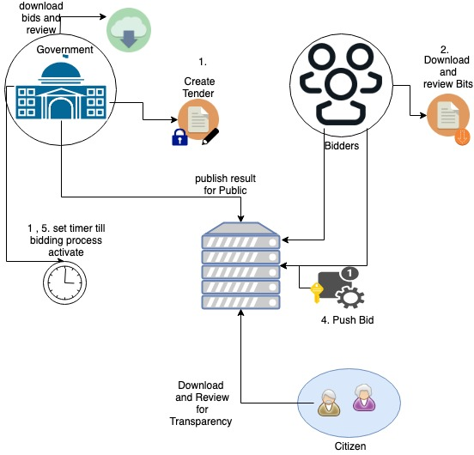

**3. Work Flow:**

**Steps Involved:**

*This image has copied from research paper...*

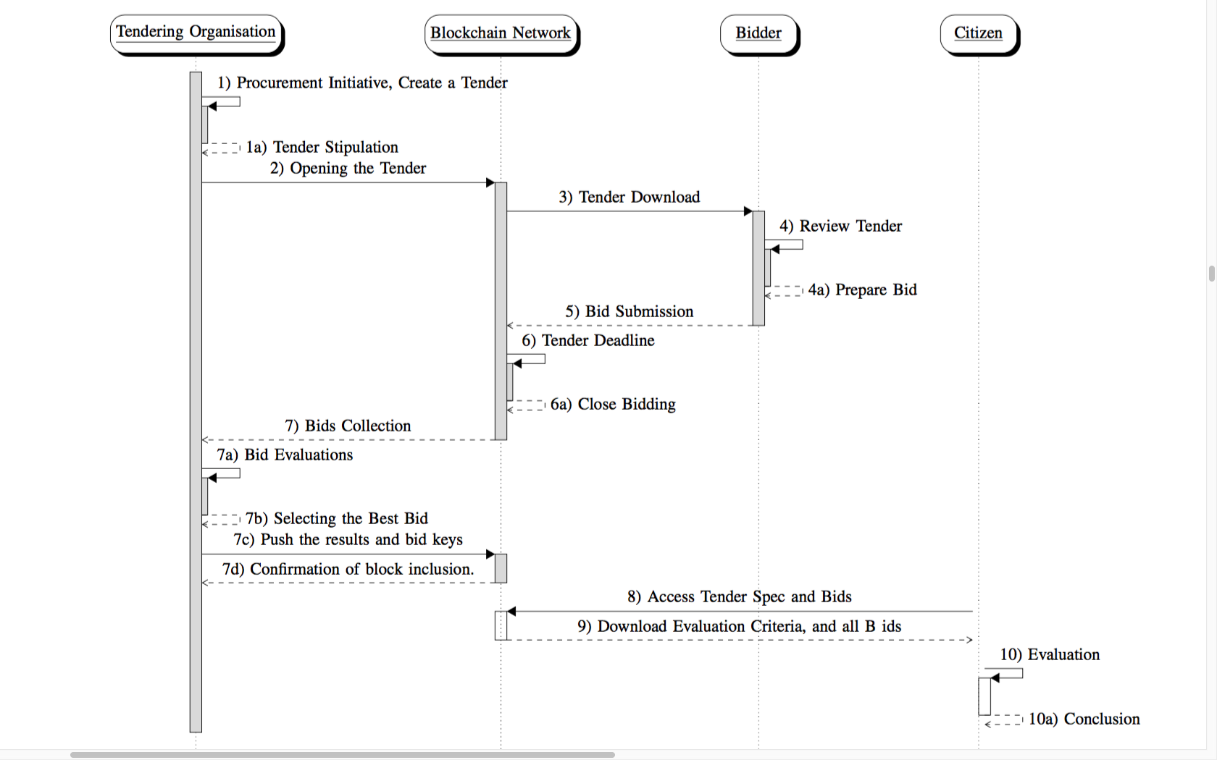

Crucial thing is smart contract:

1. Government release the tender(immutable)

2. Bidder download tender

3. Bidder review the tender and set a bid

4. Push bid (signing is important)

5. Bidding process close when time-limit end.

6. Government download bids, and evaluate it

7. Government push the evaluation result to blockchain

8. Citizen can review bids

9. Citizen can download and run evaluation for transparency

**4. List of Deliverables and Features:**

1. Smart contract platform for more feature rich, autonomous and supporting secure distributed execution.

2. Ethereum based blockchain

3. Separate entities, like government, bidder and citizens